GROUP 2: TRAM NGOC LE YANQI SHI BINGYUE ZENG ANNUO QIAN XUEJUN SHENG

QOOGLE Q&A TYPE AND TOPIC CLASSIFICATION PROJECT REPORT

Text Analytics | Prof. Evan Katsamakas | April 22nd, 2020

1. **Executive Summary**

This project was commissioned to build and evaluate classification models with different target measurements. First, content classification models for the content of question and answer based on categories. Second, type classification models for the probability of answer and question based on their types. The text analytics software application, SPSS modeler, and programming languages such as R and Python were implemented in this project.

Computers have evolved quickly nowadays and focused more on developing an algorithm to answer a question like a human. Google Search has become the domain search engine developer in the United States market since 2009. Recently, Google Research team, dedicated to advancing natural language processing and other types of machine learning, has gathered over 6k records of question-answer paired data to build predictive classification models that can perform the more human-like subjective question-answering algorithm.

Results of predictive classification models show that Support Vector Machine model with feature Term Frequency – Inverse Document Frequency (TF-IDF) in the content classification has the highest prediction accuracy in both question and answer; while Support Vector Machine model with feature TF-IDF in the type classification has the highest prediction accuracy in question, and Long Short-Term Memory model with feature TF-IDF in the type classification has the highest prediction accuracy in answer.

It is recommended to create other algorithms of feature vectors in the type classification process because TF-IDF is not good enough to distinguish between types of contexts. Furthermore, the number of instances in each type lacks proposition, so adding more data records to balancing the type instances is essential for improving model performance.

1. **Problem Statement**

Building a subjective and better human-like intelligent question and answer (Q&A) system is a cutting-edge problematic topic among data scientists, especially when combining text analytics and machine learning techniques. By improving the Q&A system, every time a customer searches on Google, the search engine will retrieve a much more precise answer that meets a desirable answer for an inquiry. The approach of building content predictive classification algorithms and type classification algorithms, and then evaluating these algorithms may demonstrate insight into that topic.

1. **Data Description**

The Google QUEST Q&A Labeling data set is featured on Kaggle, the world’s largest data science community. Google Research team, CrowdSource, collected the data from various Stack Exchange properties. Google used this data set to hold a public featured code competition for Kaggle users. The competition aims to improve automated understanding of complex question and answer content. This data set contains approximately 6500 pairs of question and answer gathered from 70 websites.

The dataset includes a training dataset and a testing dataset. Both datasets include questions id (qa_id), question_title, question_body, question_user_name, question_user_page, answers, answer_user_name, answer_user_page, url, host and categories. The training dataset also includes values of 30 labels for each question-answer pair of the question types and answer types, which need to be further processed in preprocessing steps for our models, except the questions, answers and categories.The training data contains some duplicated questions with different answers. The values of 30 labels have continuous values in the range 0 to 1.

1. **Methodology**

**Figure 1. Methodology Diagram**

**Data Preparation | Classes Labeling.**

We manually labeled our target for question type and answer type based on the probabilities score provided by the dataset. The dataset includes values of labels for each question-answer pair of the question types and answer types. To make the dataset applicable to classification, we process the dataset and give each question-answer pair two new features based on the values, which are question target and answer target. We introduce these two new features using the following rules: the label of a question with the largest value will be the question target; and if there are more than 2 largest values, the question target will be labeled as “mixed”. The same rule is applied to answer targets. The following figures provide an example.

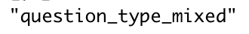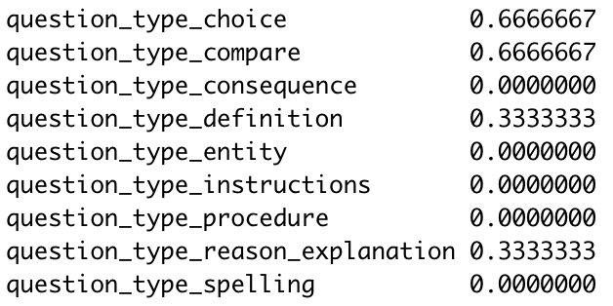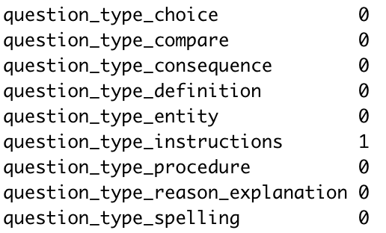

We assigned id for each category, answer type and question type based on our target.

**Variables Selection**

In part one, Q&A category classification, we assigned “category” as our target. “Question_body” and “answer” are selected as the inputs for feature extraction and feature engineering.

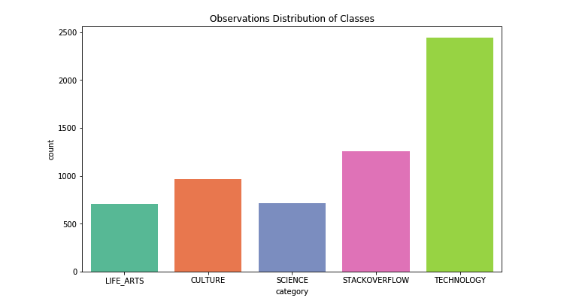Based on initial descriptive statistical analysis, the categories of question and answer pairs are skewed towards Technology and Stackoverflow category, which contains 40% and 21% of the dataset’s observations, respectively. Therefore, the problem of imbalanced classes emerges in this dataset. When encountering such problem, there are absolutely difficulties to classification with standard algorithm as the model can be biased towards the majority class.

**Figure 2**. **Category Distribution**

In part two, Q&A type classification, we assigned “target_answer_mix” and “answer_target_mix”, which we generated with the highest probabilities score from each question type features and answer type features from the train data set Kaggle provides. Next, we considered question_body and answer as the input for feature extraction and feature engineering in order to build our predictive models.

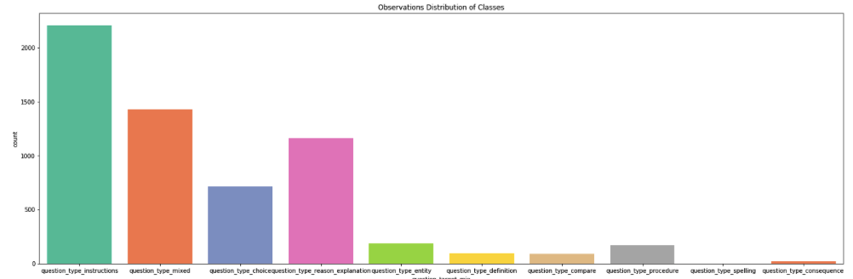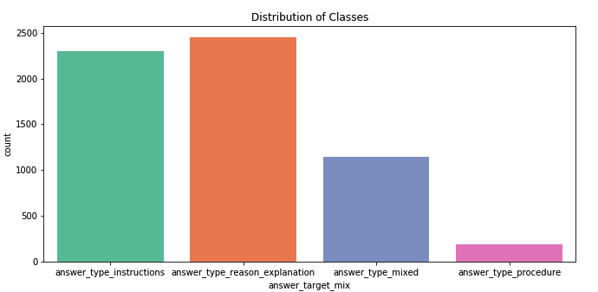The initial descriptive analysis also shows that there are extremely unbalanced classes in this data set. Regarding question type target distribution of observations, most observations are remained in instruction type, mixed type, choice type, and reason explanation type among 10 classes. Regarding answer type target distribution of observations, answer type procedure is extremely unbalanced towards other classes as this class provides the lowest number of observations.

**Figure 3. Question Type Distribution Figure 4. Answer Type Distribution**

**Text Preprocessing**

We started off with preprocessing the question body and answer corpuses in preparation of the feature engineering process. We used the nltk package to perform stop-words removal, stemming and lemmatization, punctuation filtering and lowercase. We did not remove all punctuations because some of those might be suitable for the context of technology, stack overflow, or science in category classification part as well as the the structure of question and answer type in types classification part.

**Part I: Category/Topic Classification**

**Feature Engineering:** We extracted three features separately from the question body and answer corpuses, including TFIDF, Word2Vec, and Bag-of-Word (BOW).

* **TFIDF**: We extracted TFIDF vectors from the corpus. For TFIDF engineering, we normalized TFIDF term frequency with logarithmic form, minimized the numbers of document a word must be present to be kept to 1, used Euclidean norm of 1 for all features vector, smoothed inversed document frequency weights to prevent zero divisions, and considered both unigram and bigram.

The demo of top 5 correlated keywords for unigram and bigram, using TFIDF vectors, regarding each topic is demonstrated as follow:

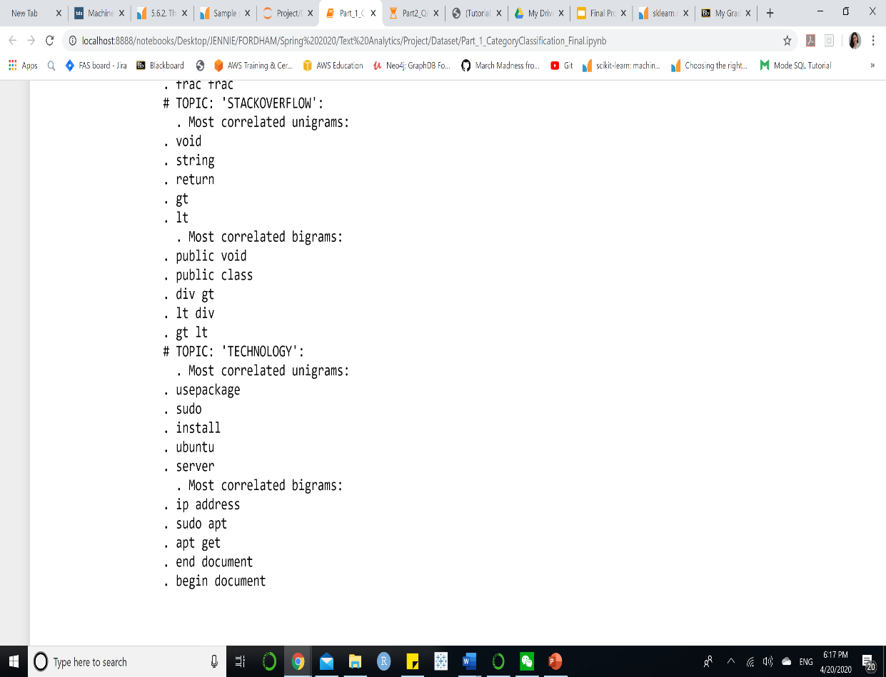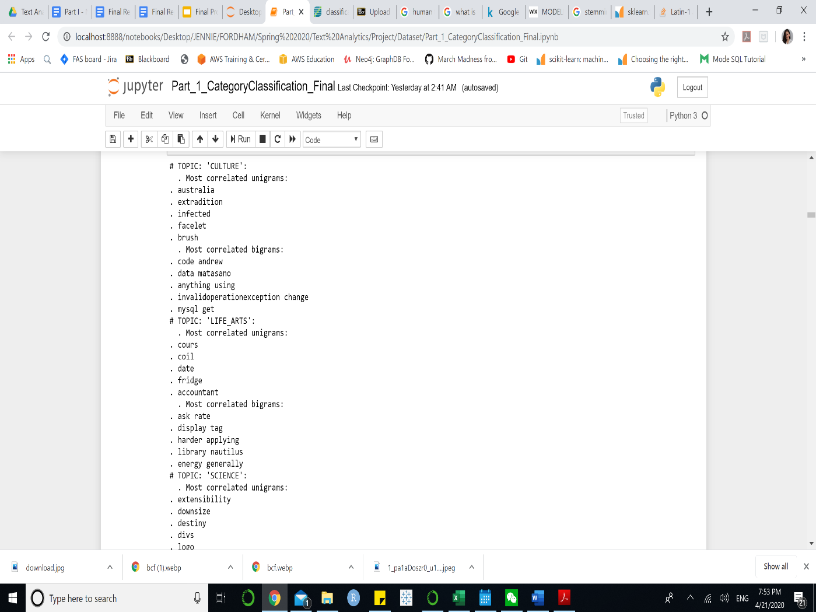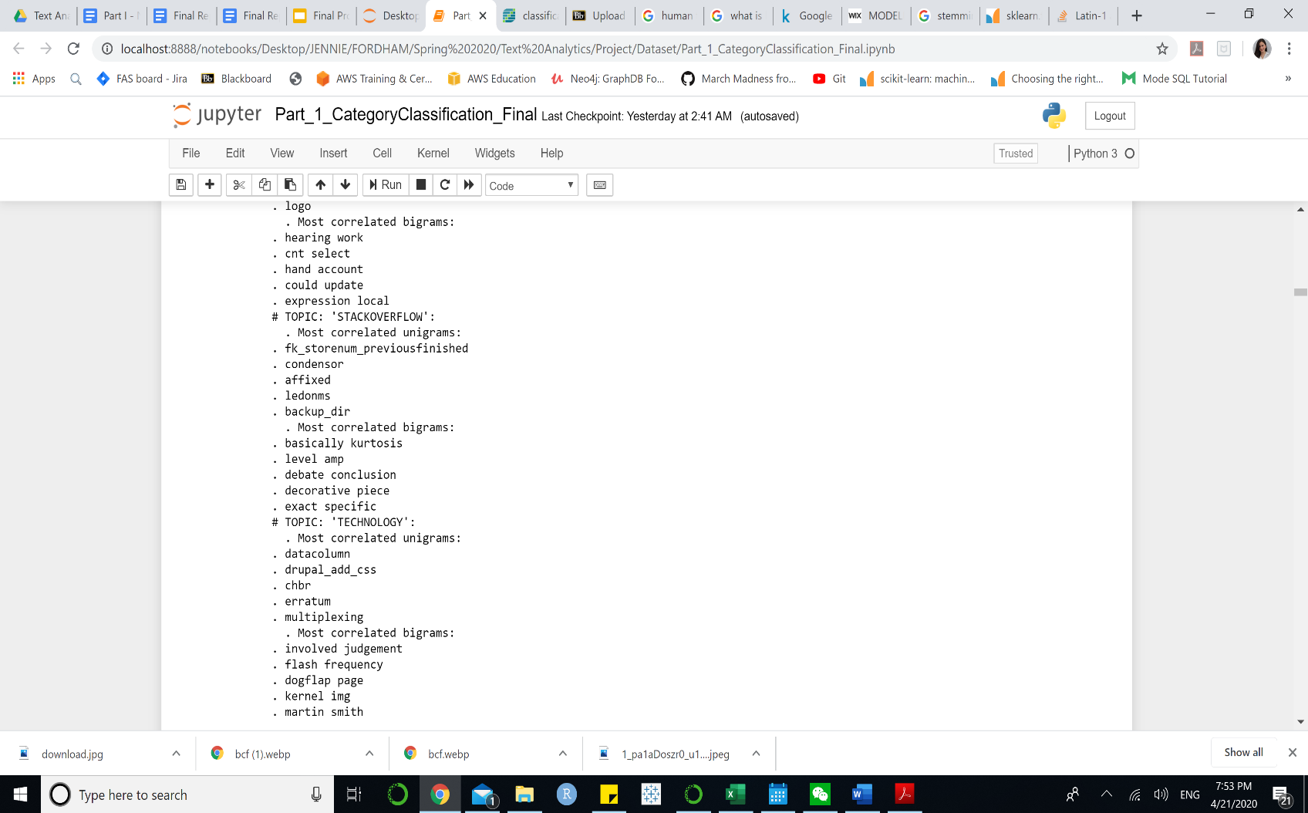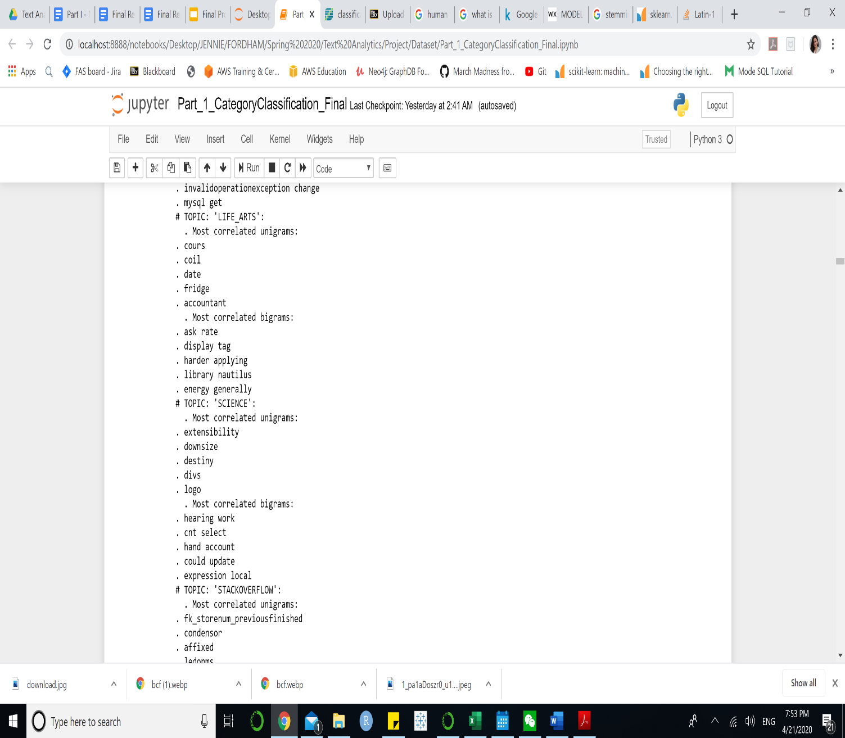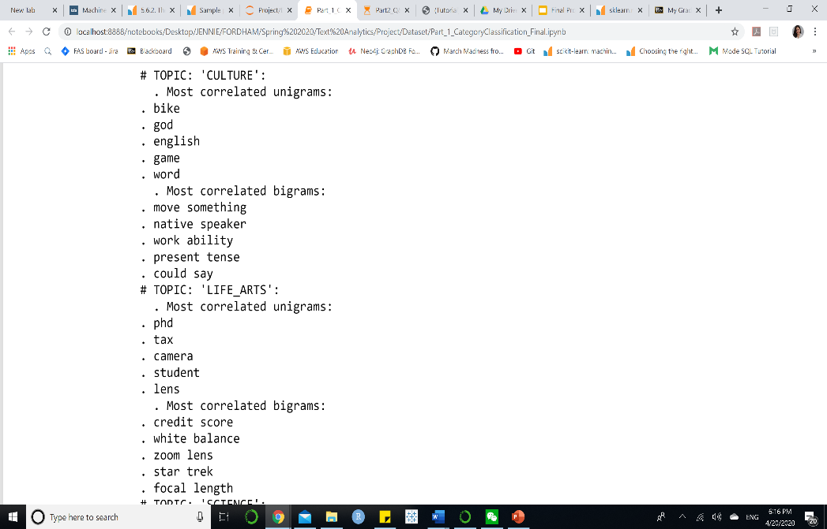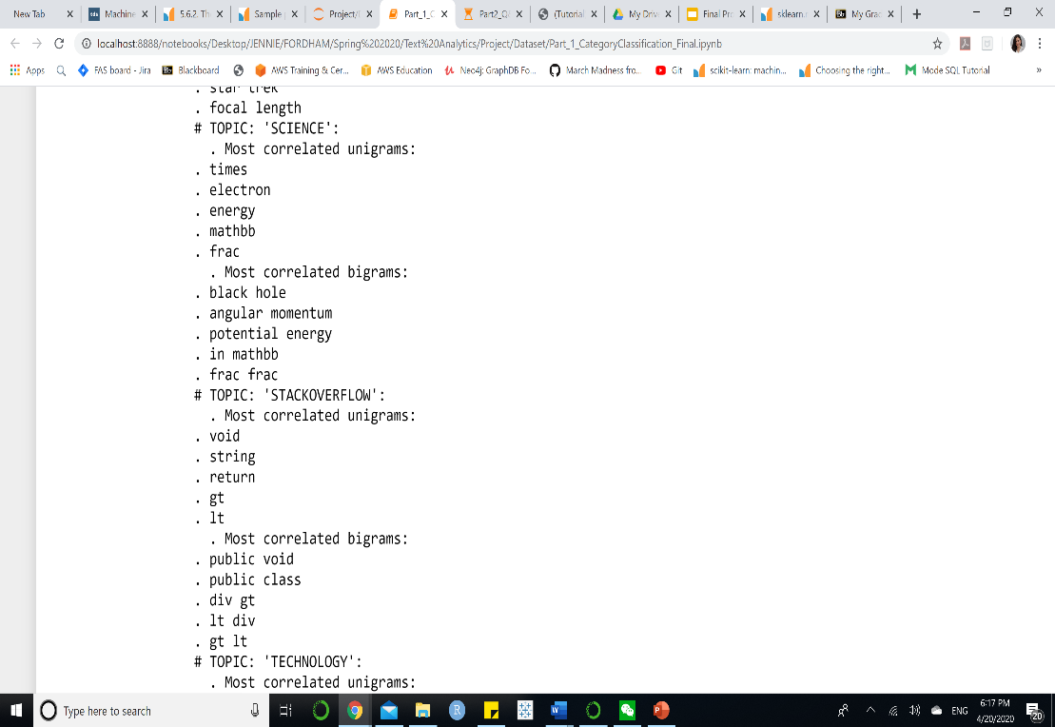**Question Answer**

* **Bag-of-Word (BOW):** We performed tokenization and count frequency of each token. We set the minimum of document frequency to 1 and only use unigram in this case.
* **Word2Vec:**

Through trials of fitting the models with each of the features, we have found that mostly **TFIDF performs the best** among the three features. Bag-of-words might perform well with Naïve Bayes but the accuracy rate is lower than TFIDF with Support Vector Machine. For further details, review the Appendix section in our jupyter notebook. In conclusion, we select **TFIDF** as our feature.

**Oversampling:** Due to the unbalanced classes problem in our data set, we decide to apply Synthetic Minority Oversampling Technique (SMOTE) to random oversample the training data set with TFIDF features.

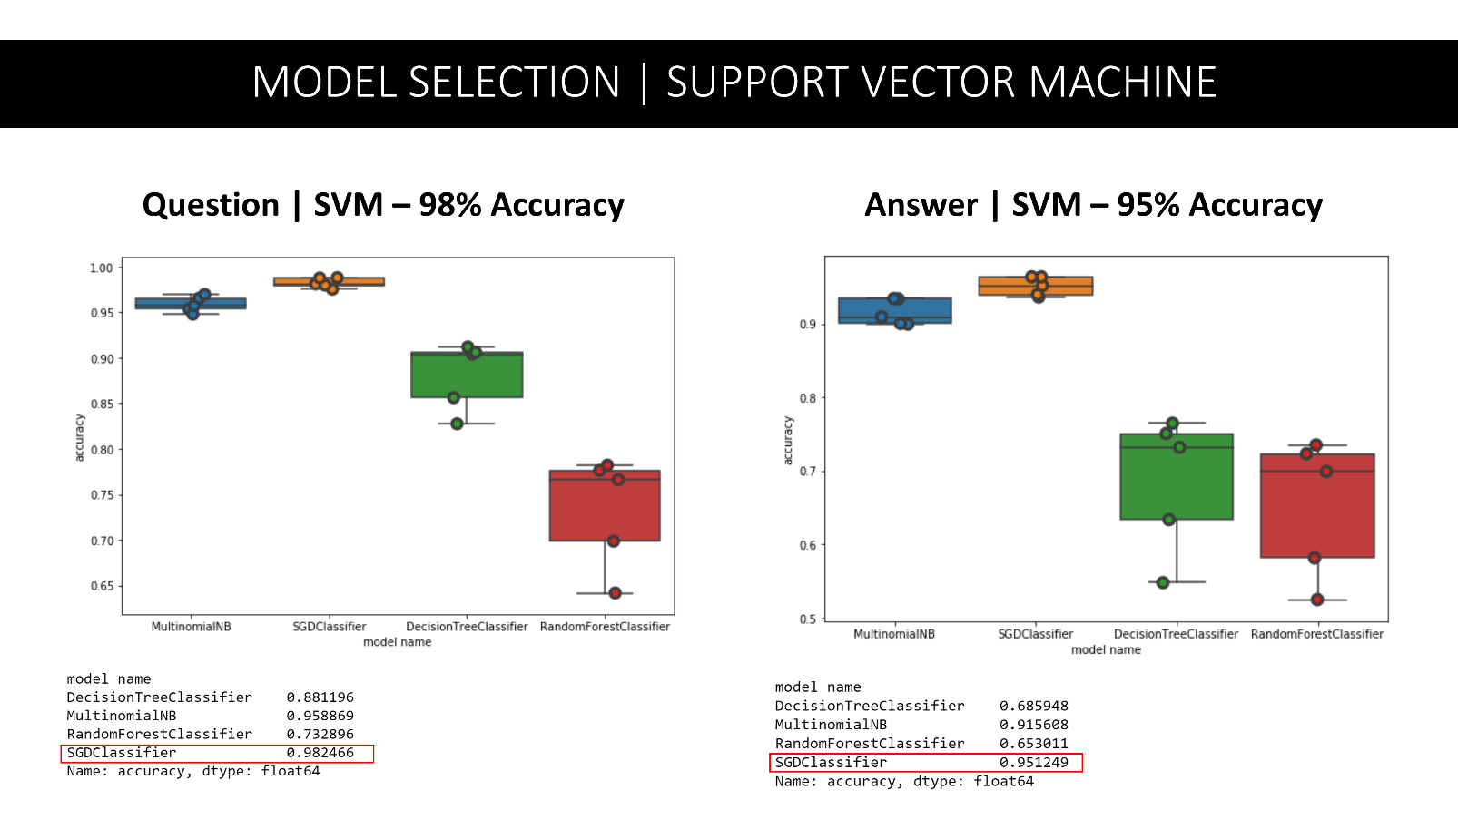**Model Building:** We decided to try different algorithms to classify 5 topics of culture, science, technology, life_arts and stackoverflow. Those models are Naïve Bayes, Support Vector Machine, Decision Tree and Random Forest.

**Figure 5. Model Selection (Accuracy on Training)**

**Model Selection:** We performed 5-fold cross-validation on the training dataset and evaluate the model selection based on accuracy rate of the training data set. Support Vector Machine performs the best among all other models. It provides 98% of accuracy for question and 95% accuracy for answer on topic classification. Next, we fitted Support Vector Machine on the testing data set and evaluate the model.

**Model Evaluation:** We used precision score, recall score and F-1 score to evaluate the model

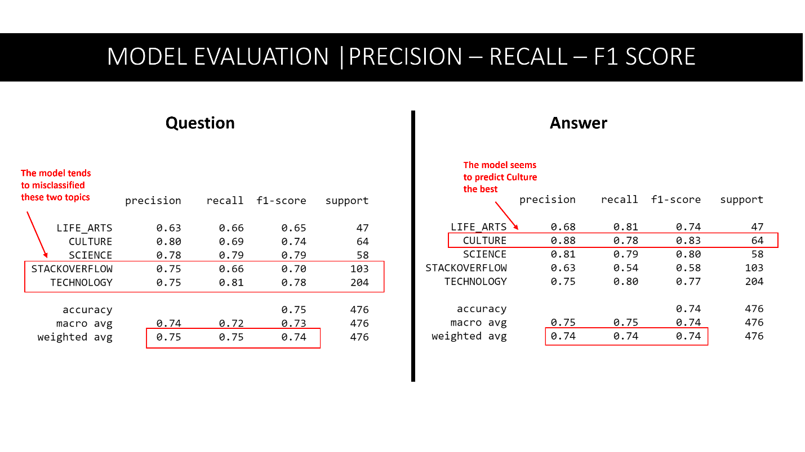

**Figure 6. Precision, Recall, F1 Score (Testing Data)**

For Question category/topic classification, Support Vector Machine performs on testing data with 0.75 for precision score and recall score and 0.71 for F1-score. Regarding each topic, the precision score ranges from 63% to 80%, which indicates a good performance. Out of all questions that are labeled as culture, technology, stackoverflow, science and life arts, the model predicts, respectively, 80%, 75%, 75%,78% and 63% of them correctly.

For Answer category/topic classification, Support Vector Machine performs on testing data with 0.74 for all precision, recall and F-1 score. Those scores are slightly lower compared to that of the question. In general, regarding each class, out of all questions that are labeled as culture, science, stackoverflow, technology, and life arts, the model predicts, respectively 88%, 81%, 63%, 75%, and 68% of them correctly.

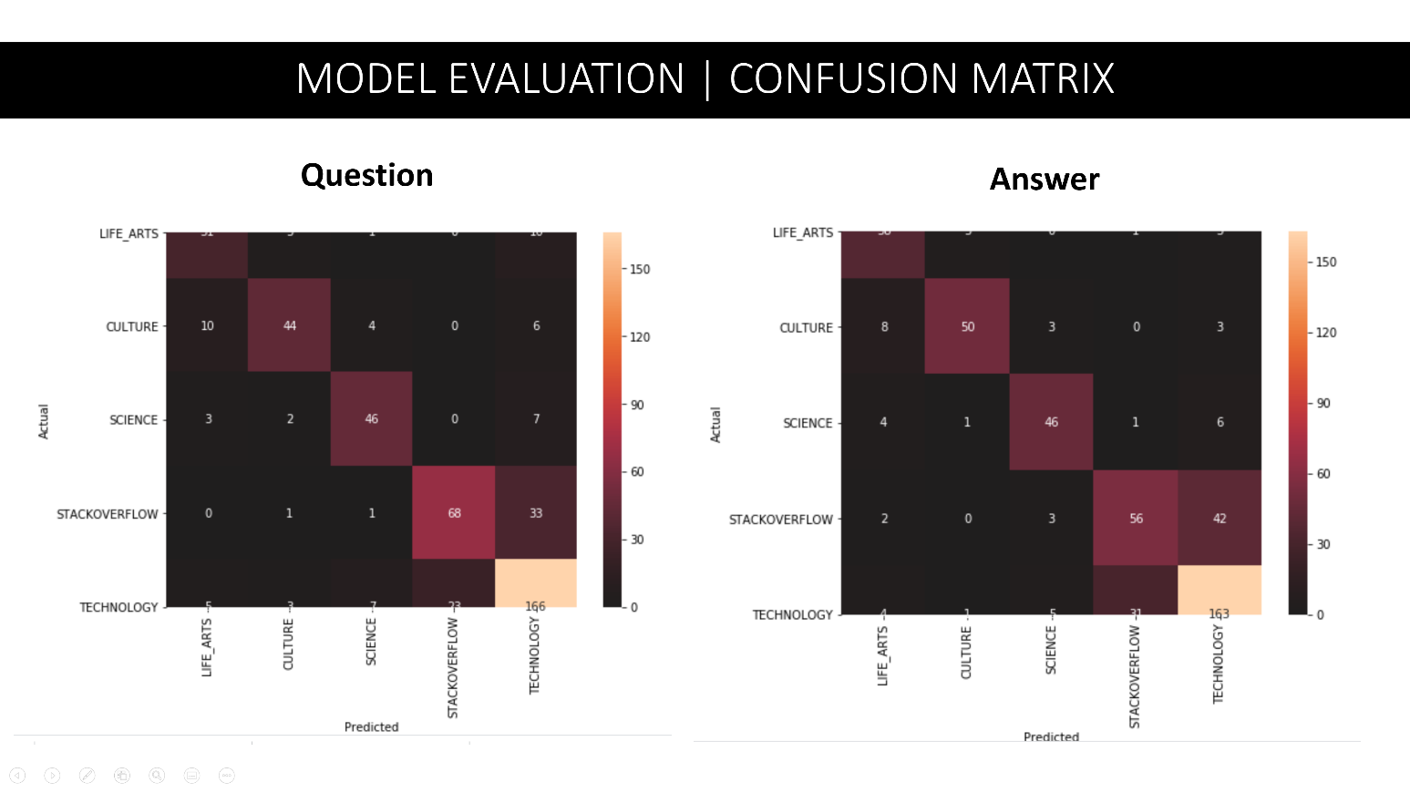**Figure 7. Confusion Matrices**

Looking at the confusion matrices, the number of technology questions are the highest correct prediction. However, at the same time, the number of observations labeled as technology is the highest, therefore, we need to look at each class to consider the performance of the model. In general, the model performs prediction the most accurately on questions and answers labeled as culture. On the other hand, the model might confuse between stackoverflow and technology since those topics contain similar keywords relating to code or software.

**Part II: Q&A Type Classification**

In the second part of our project, we classify 10 types of questions and 4 types of answers. We evaluated different algorithms, including Support Vector Machine, Naïve Bayes, Long Short-Term Memory Recurrent Neural Network, and Artificial Neural Network to decide the best models for question and answer type classification. We separated the first three models using Python with the final model using SPSS Modeler.

Besides, we only used training data set of Kaggle for this part. We partitioned training and testing into 80-20 ratio.

* **SVM | Naïve Bayes | Long Short-Term Memory**

**Feature Engineering:** We extracted 2 types of features, 1000 first word counts and TFIDF vectors. After trials, TFIDF still perform better. Therefore, we applied TFIDF features of part one to part two. We normalized TFIDF term frequency and considered both unigram and bigram.

Here are some examples of the top correlated keywords as unigram and bigram of TFDF features

* 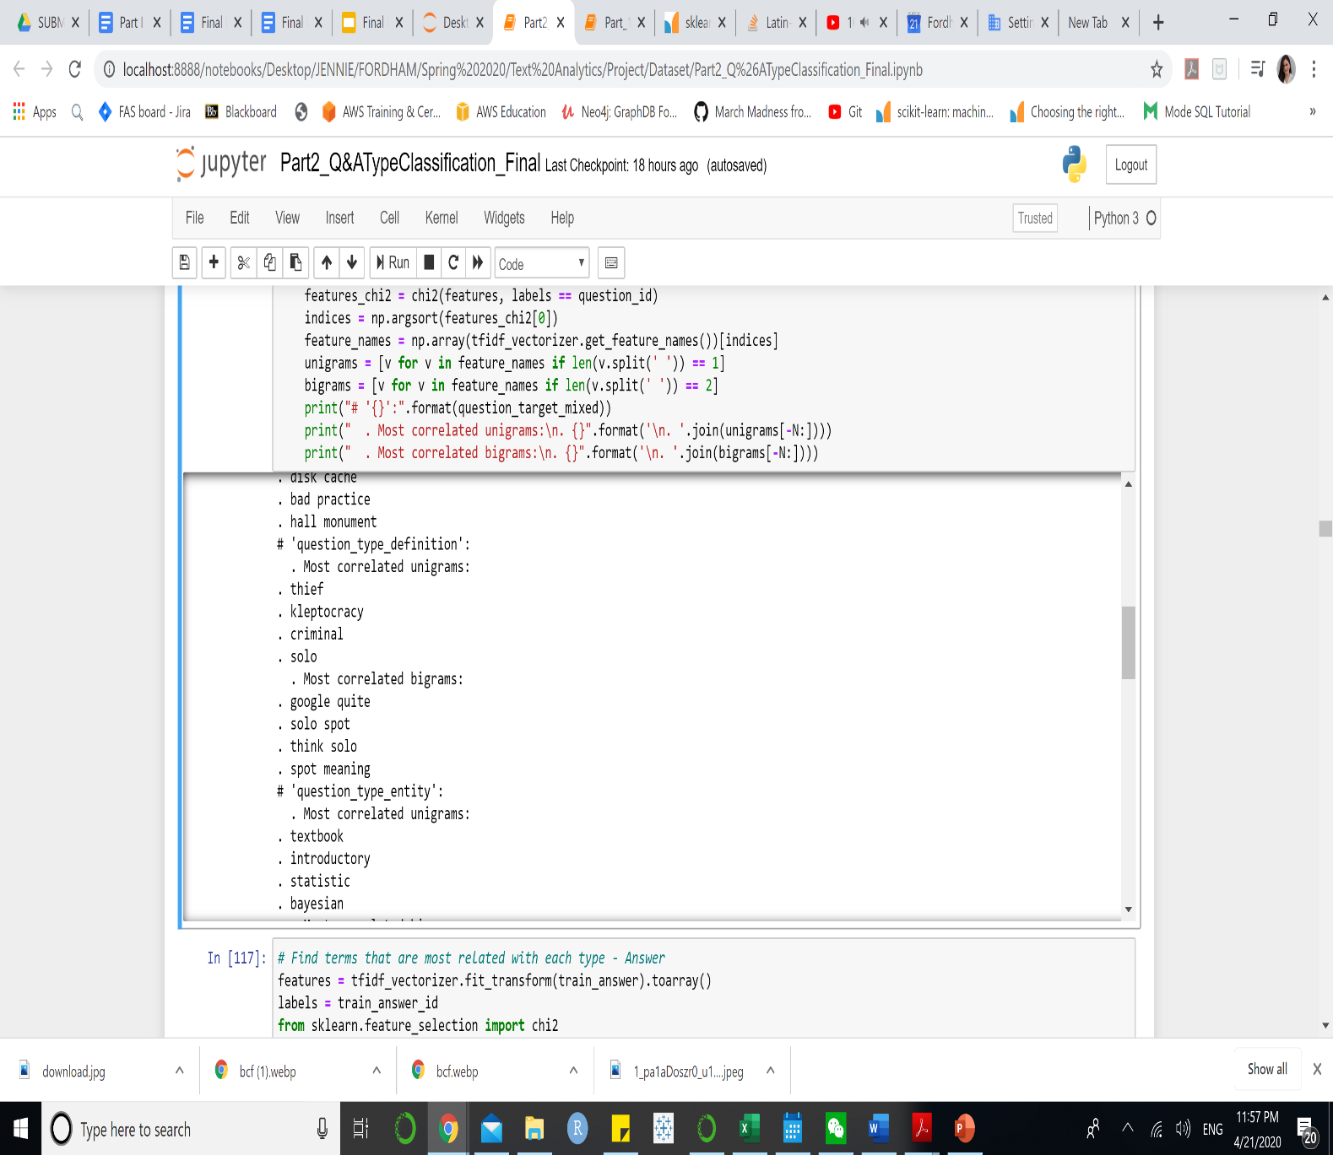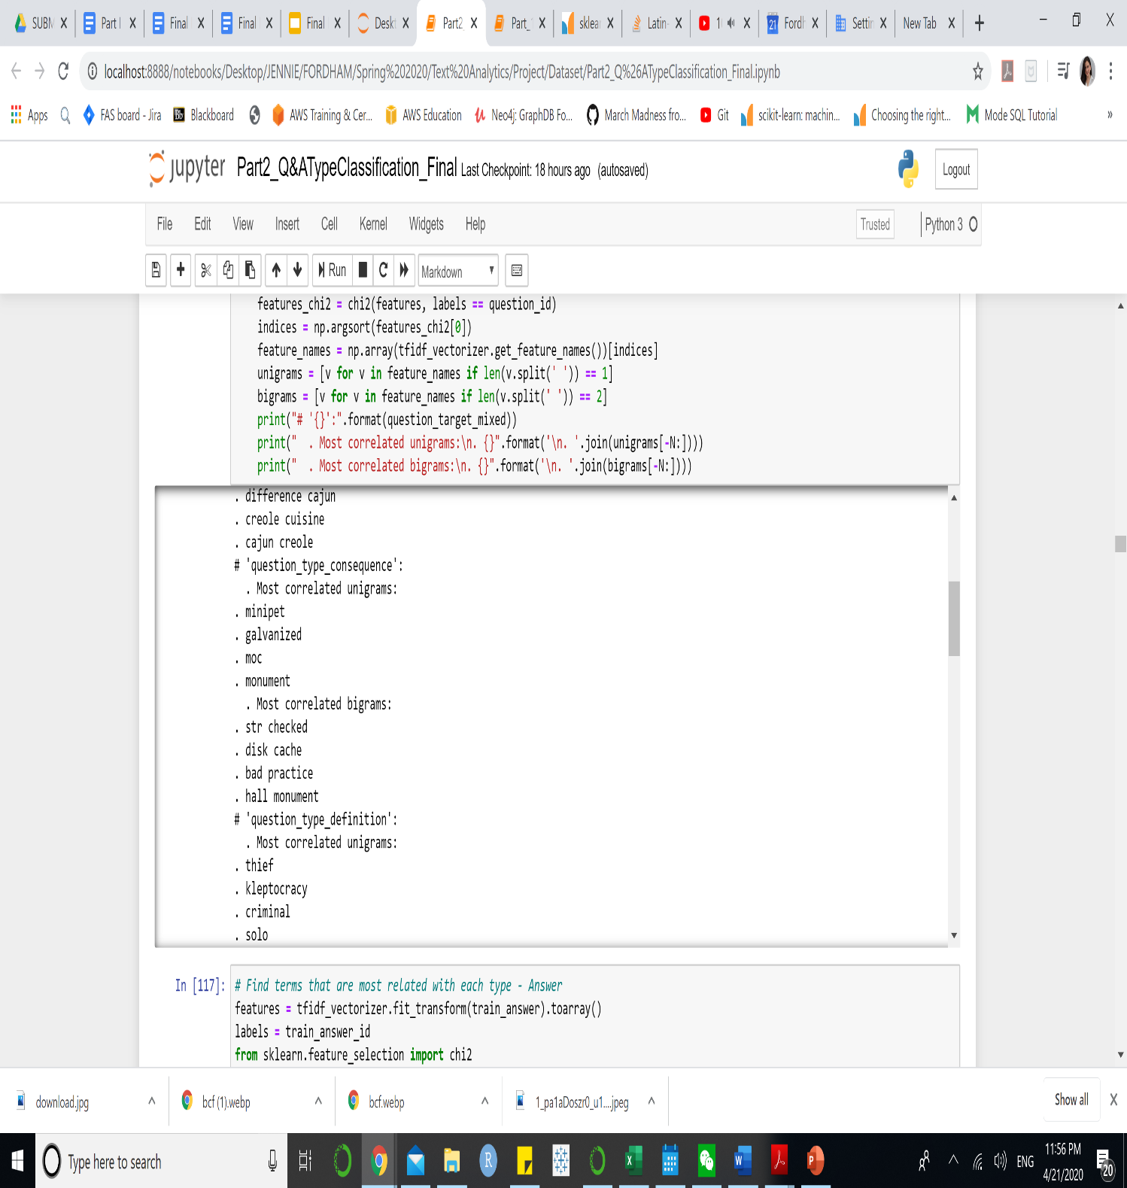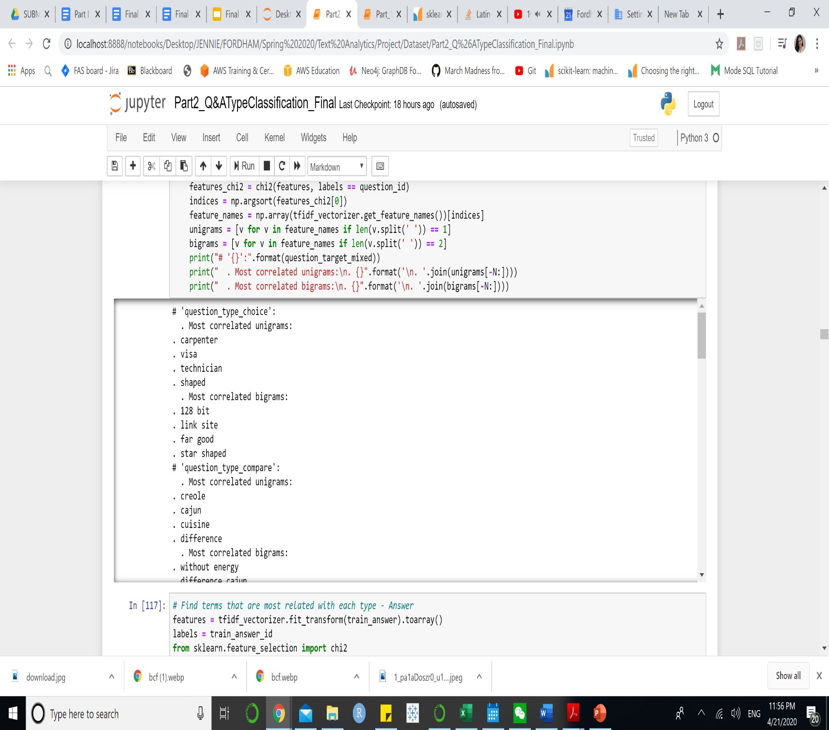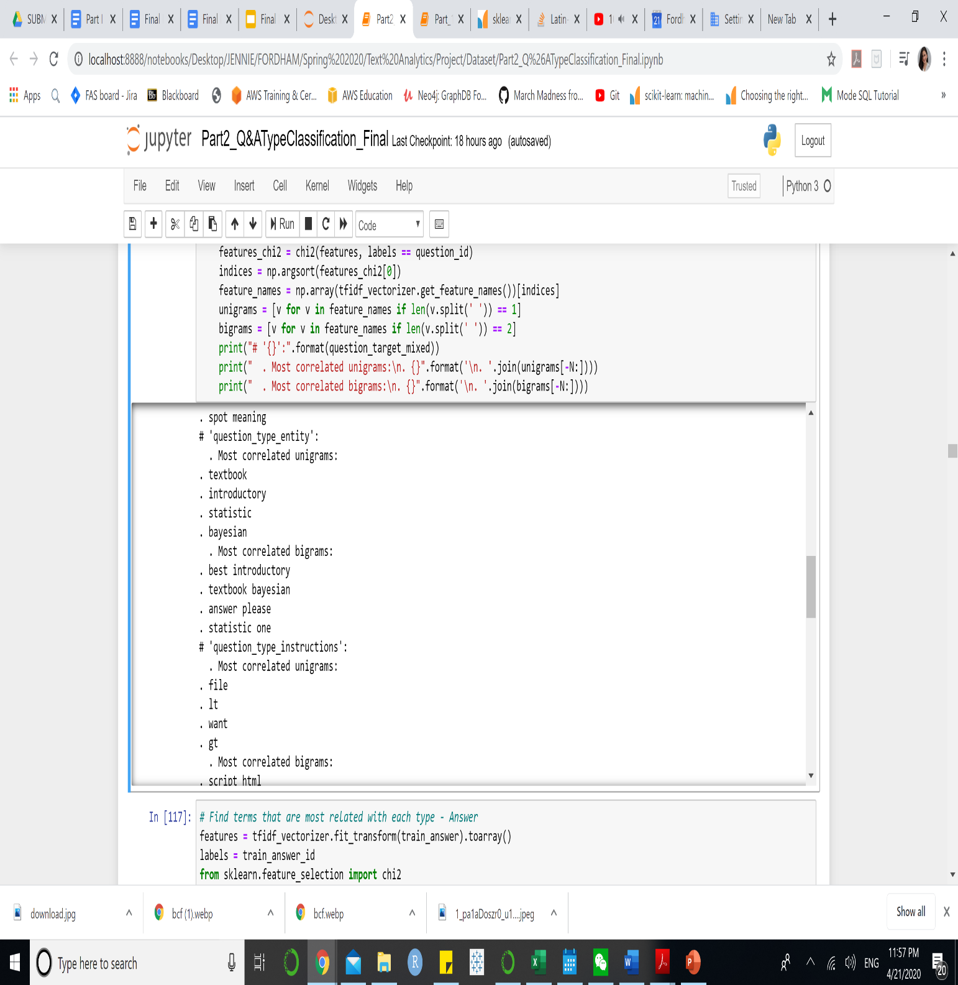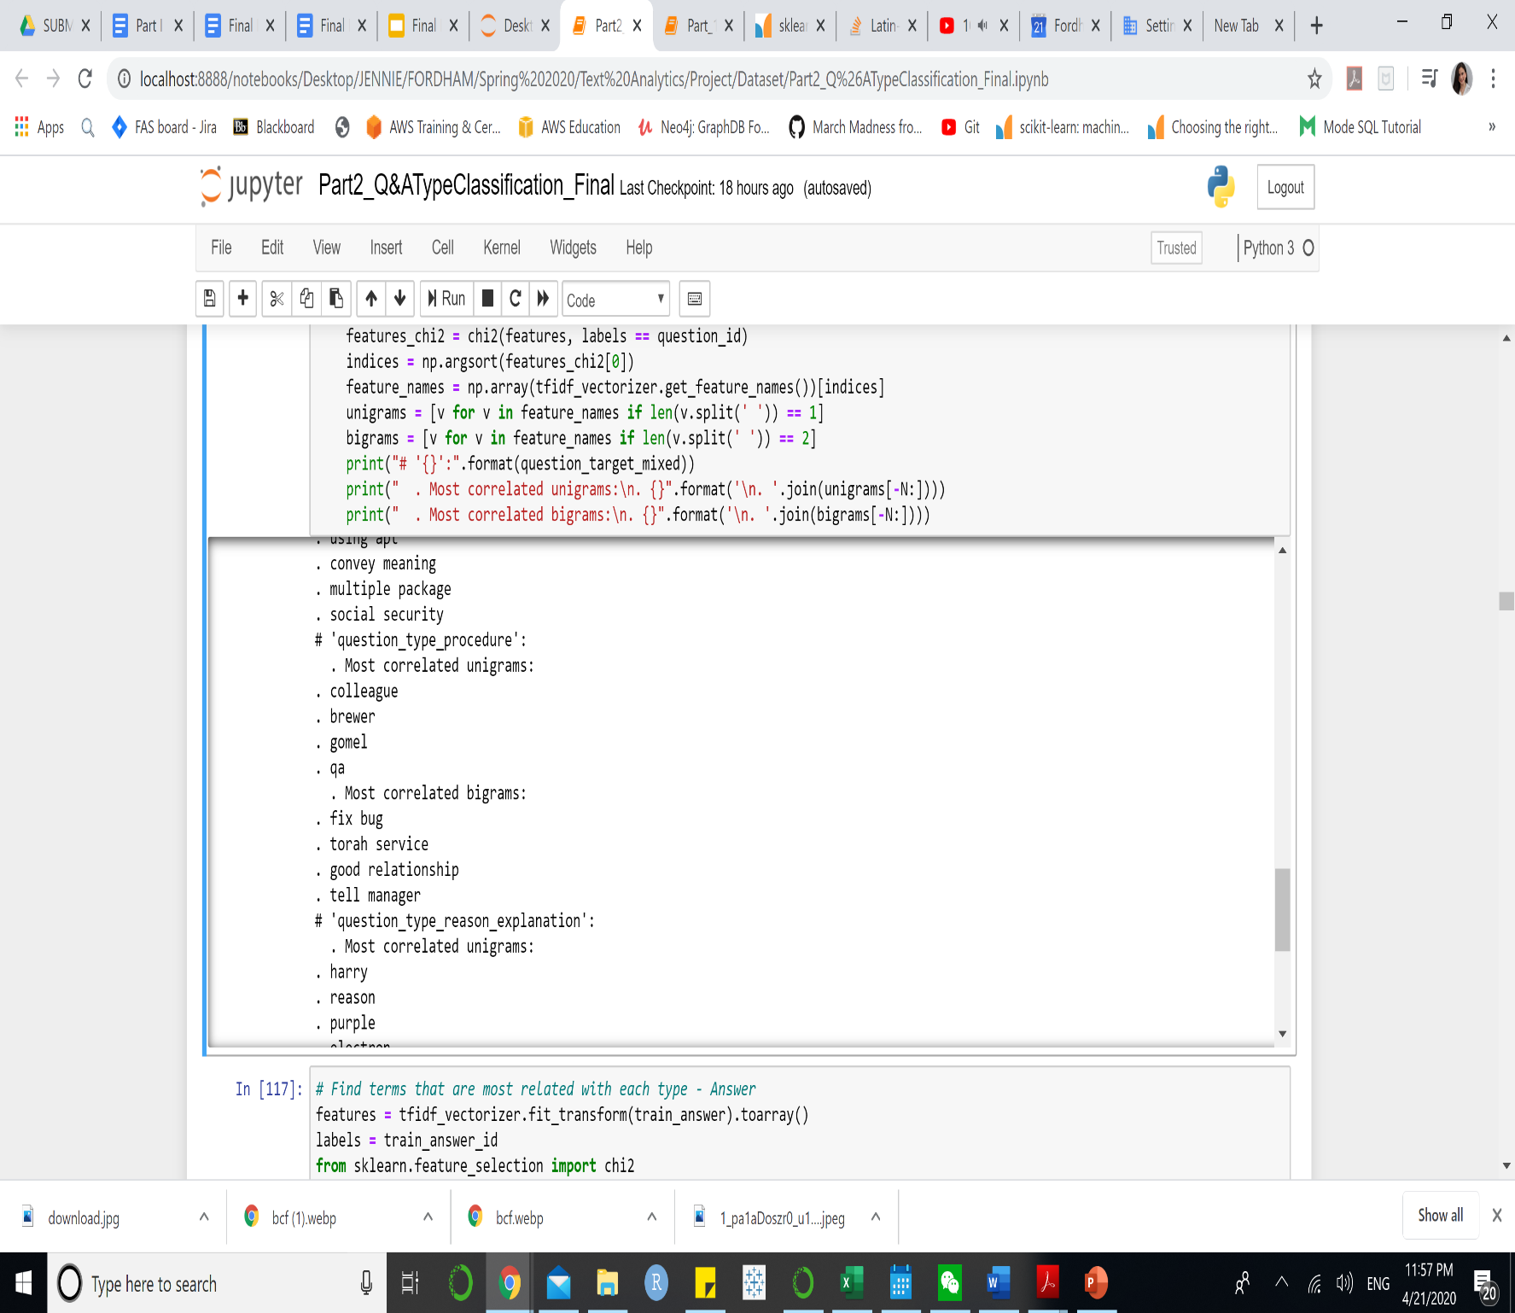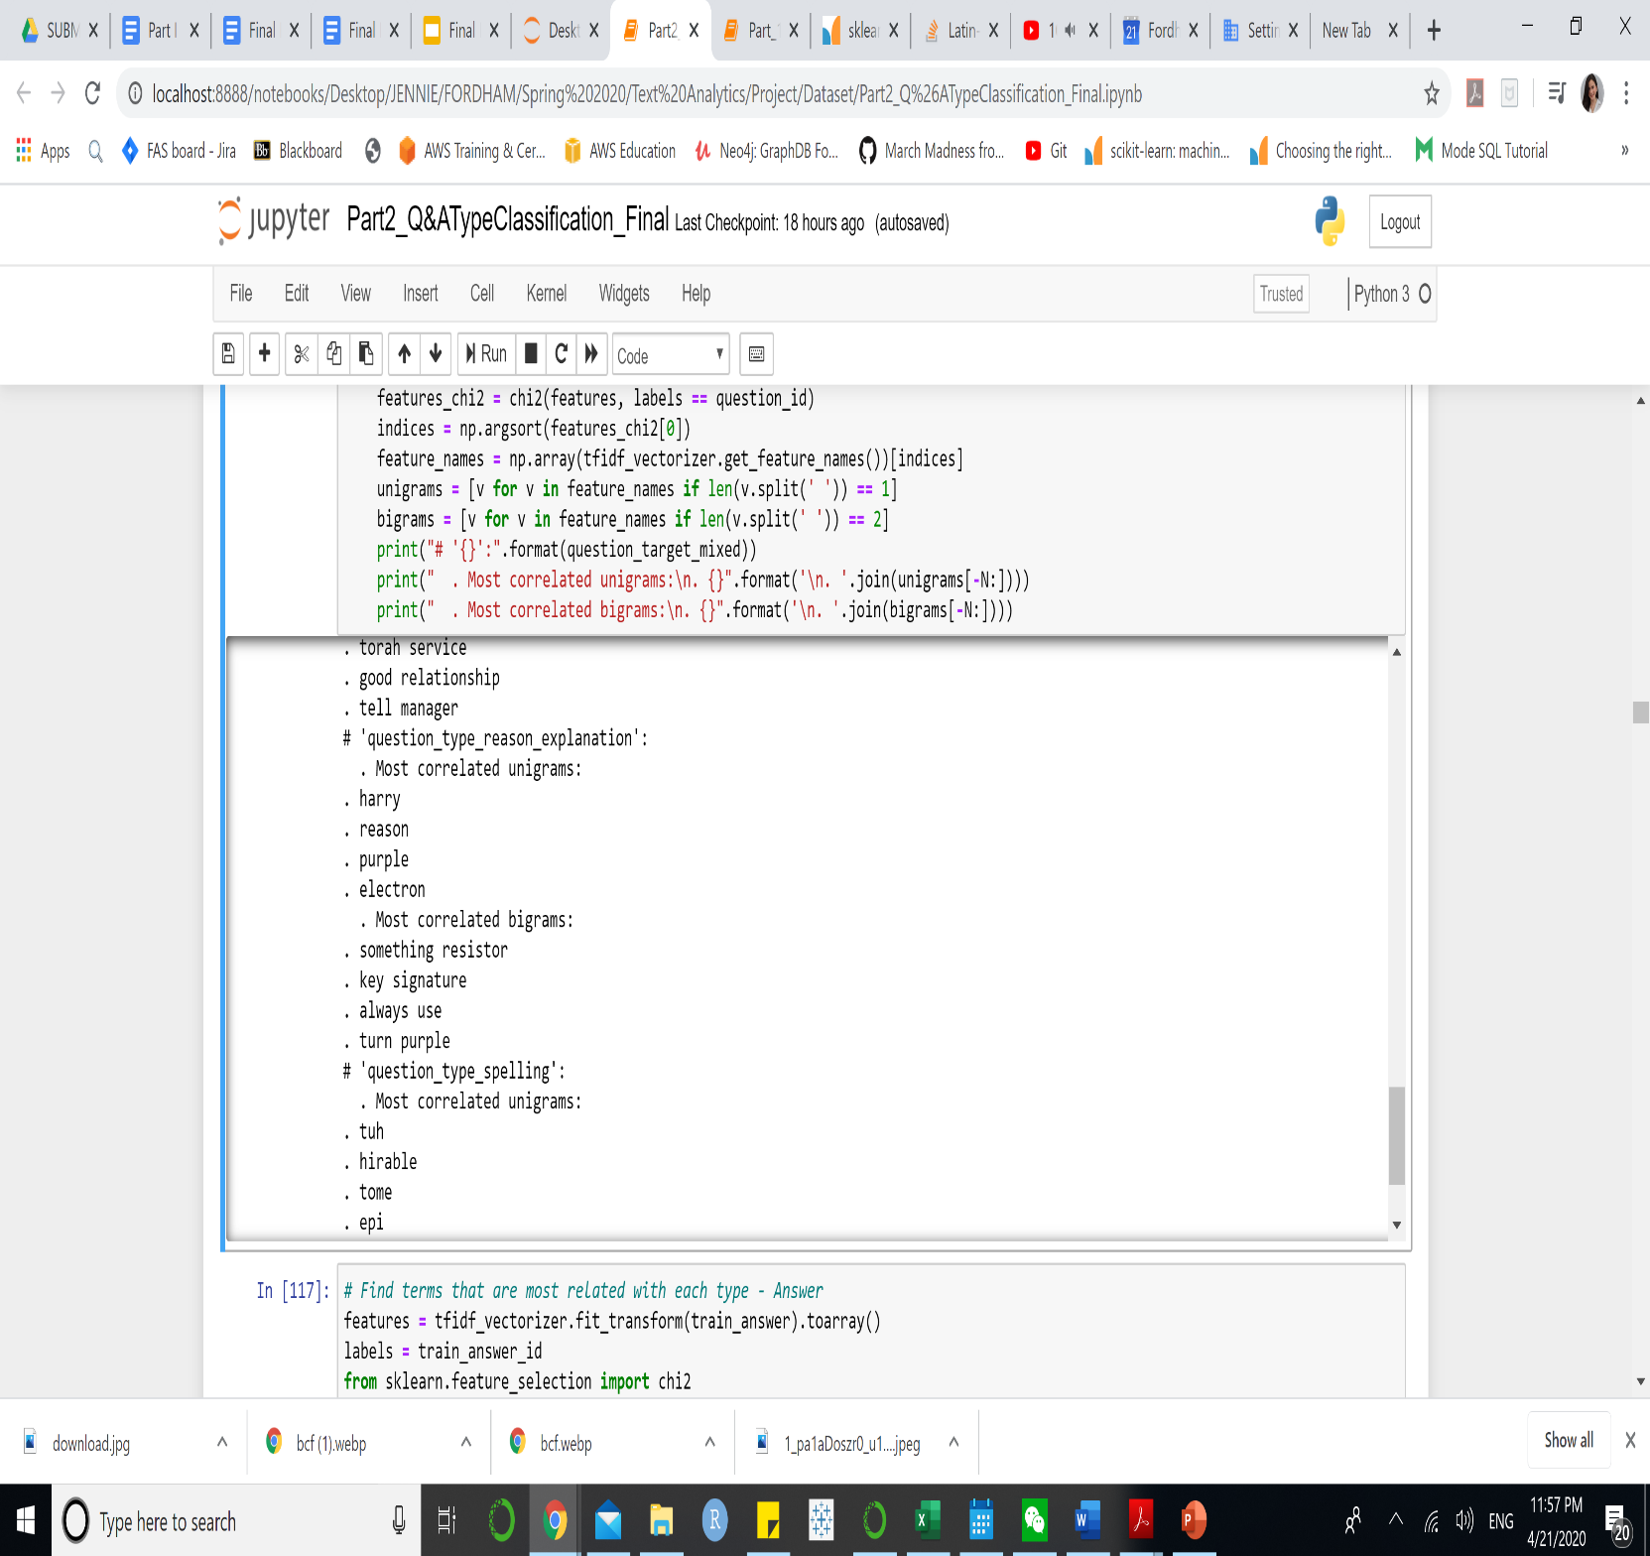Question
* 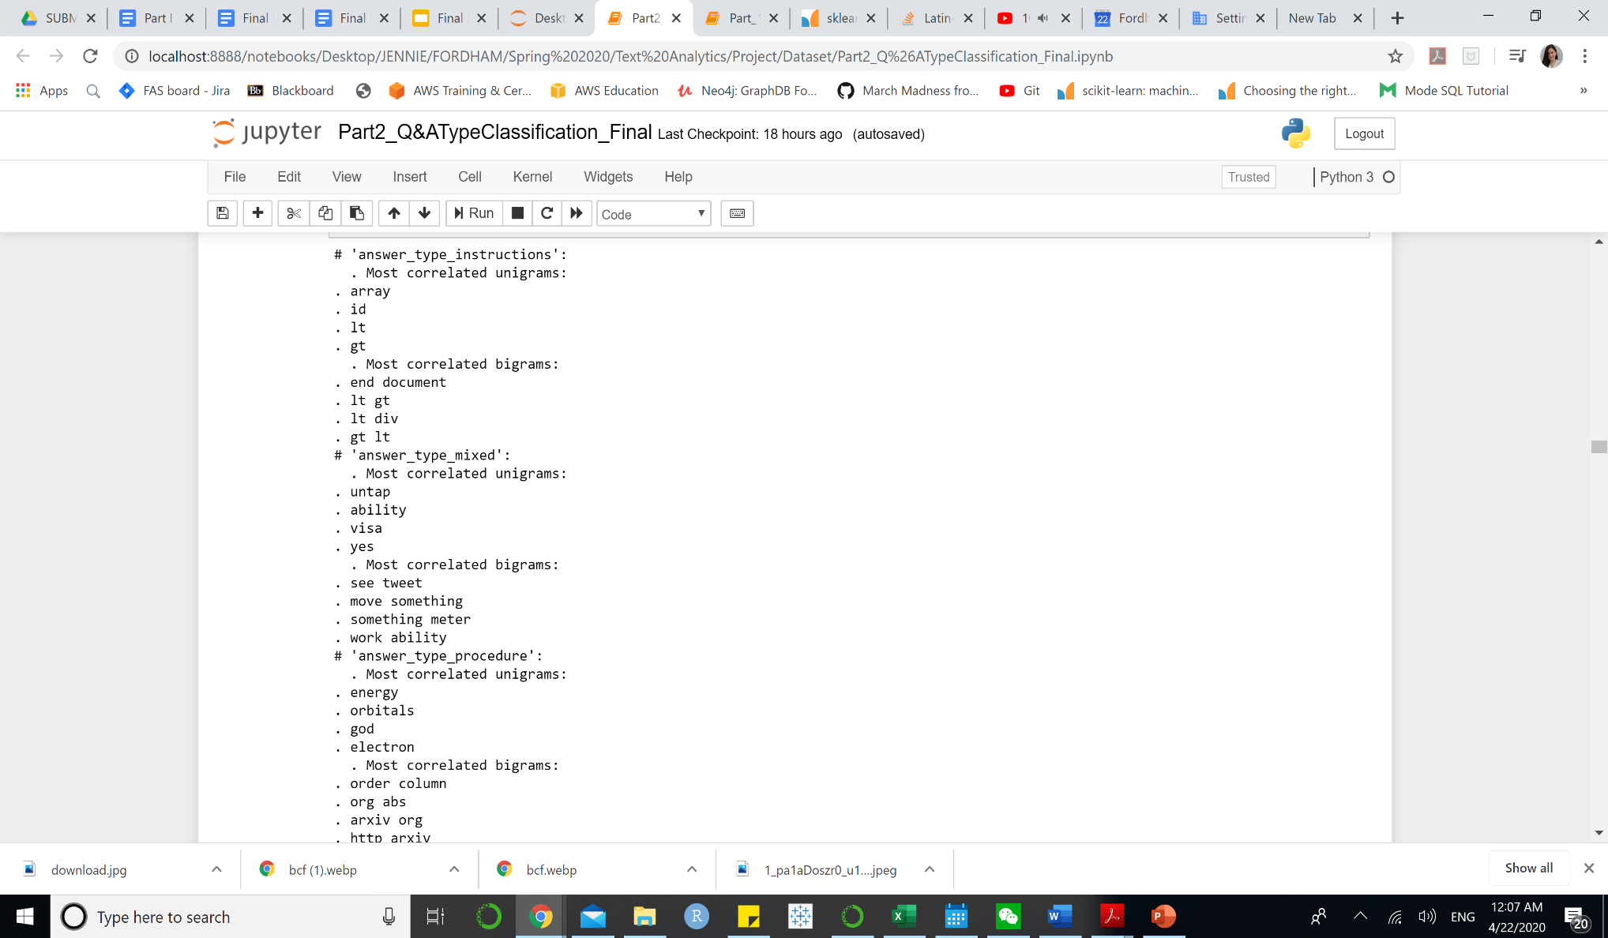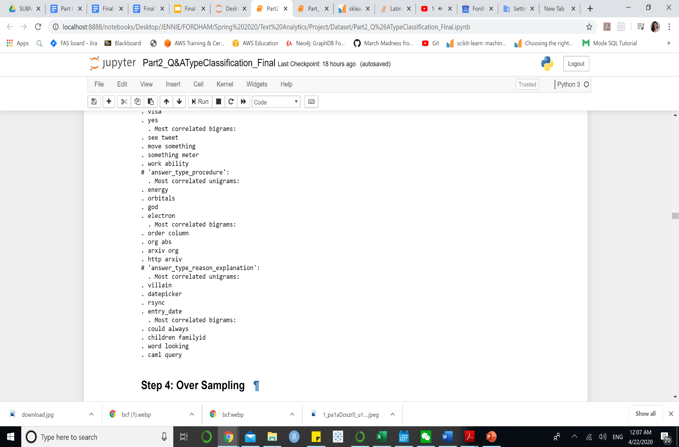Answer

**Model Building:** We chose Support Vector Machine, Naïve Bayes, and Long Short-Term Memory. For Long Short-Term Memory, we performed one hot encoding on the target of question and answer, set weight to the model to deal with imbalanced classes, train for two times and set validation dataset as 20% of the training data. The class weight is calculated based on the proportion of observations of each class against the whole data set.

**Model Selection:** For question type classification, even though Support Vector Machine performs 89.19% accurately on training data, which is slightly lower than LSTM does of 91.2%, Support Vector Machine performs the best on training data with the highest accuracy rate of 50.82%. On the other hand, for answer type classification, LSTM remains as the best classifier with the highest accuracy on training and testing data, 96.9% and 63.89%, respectively.

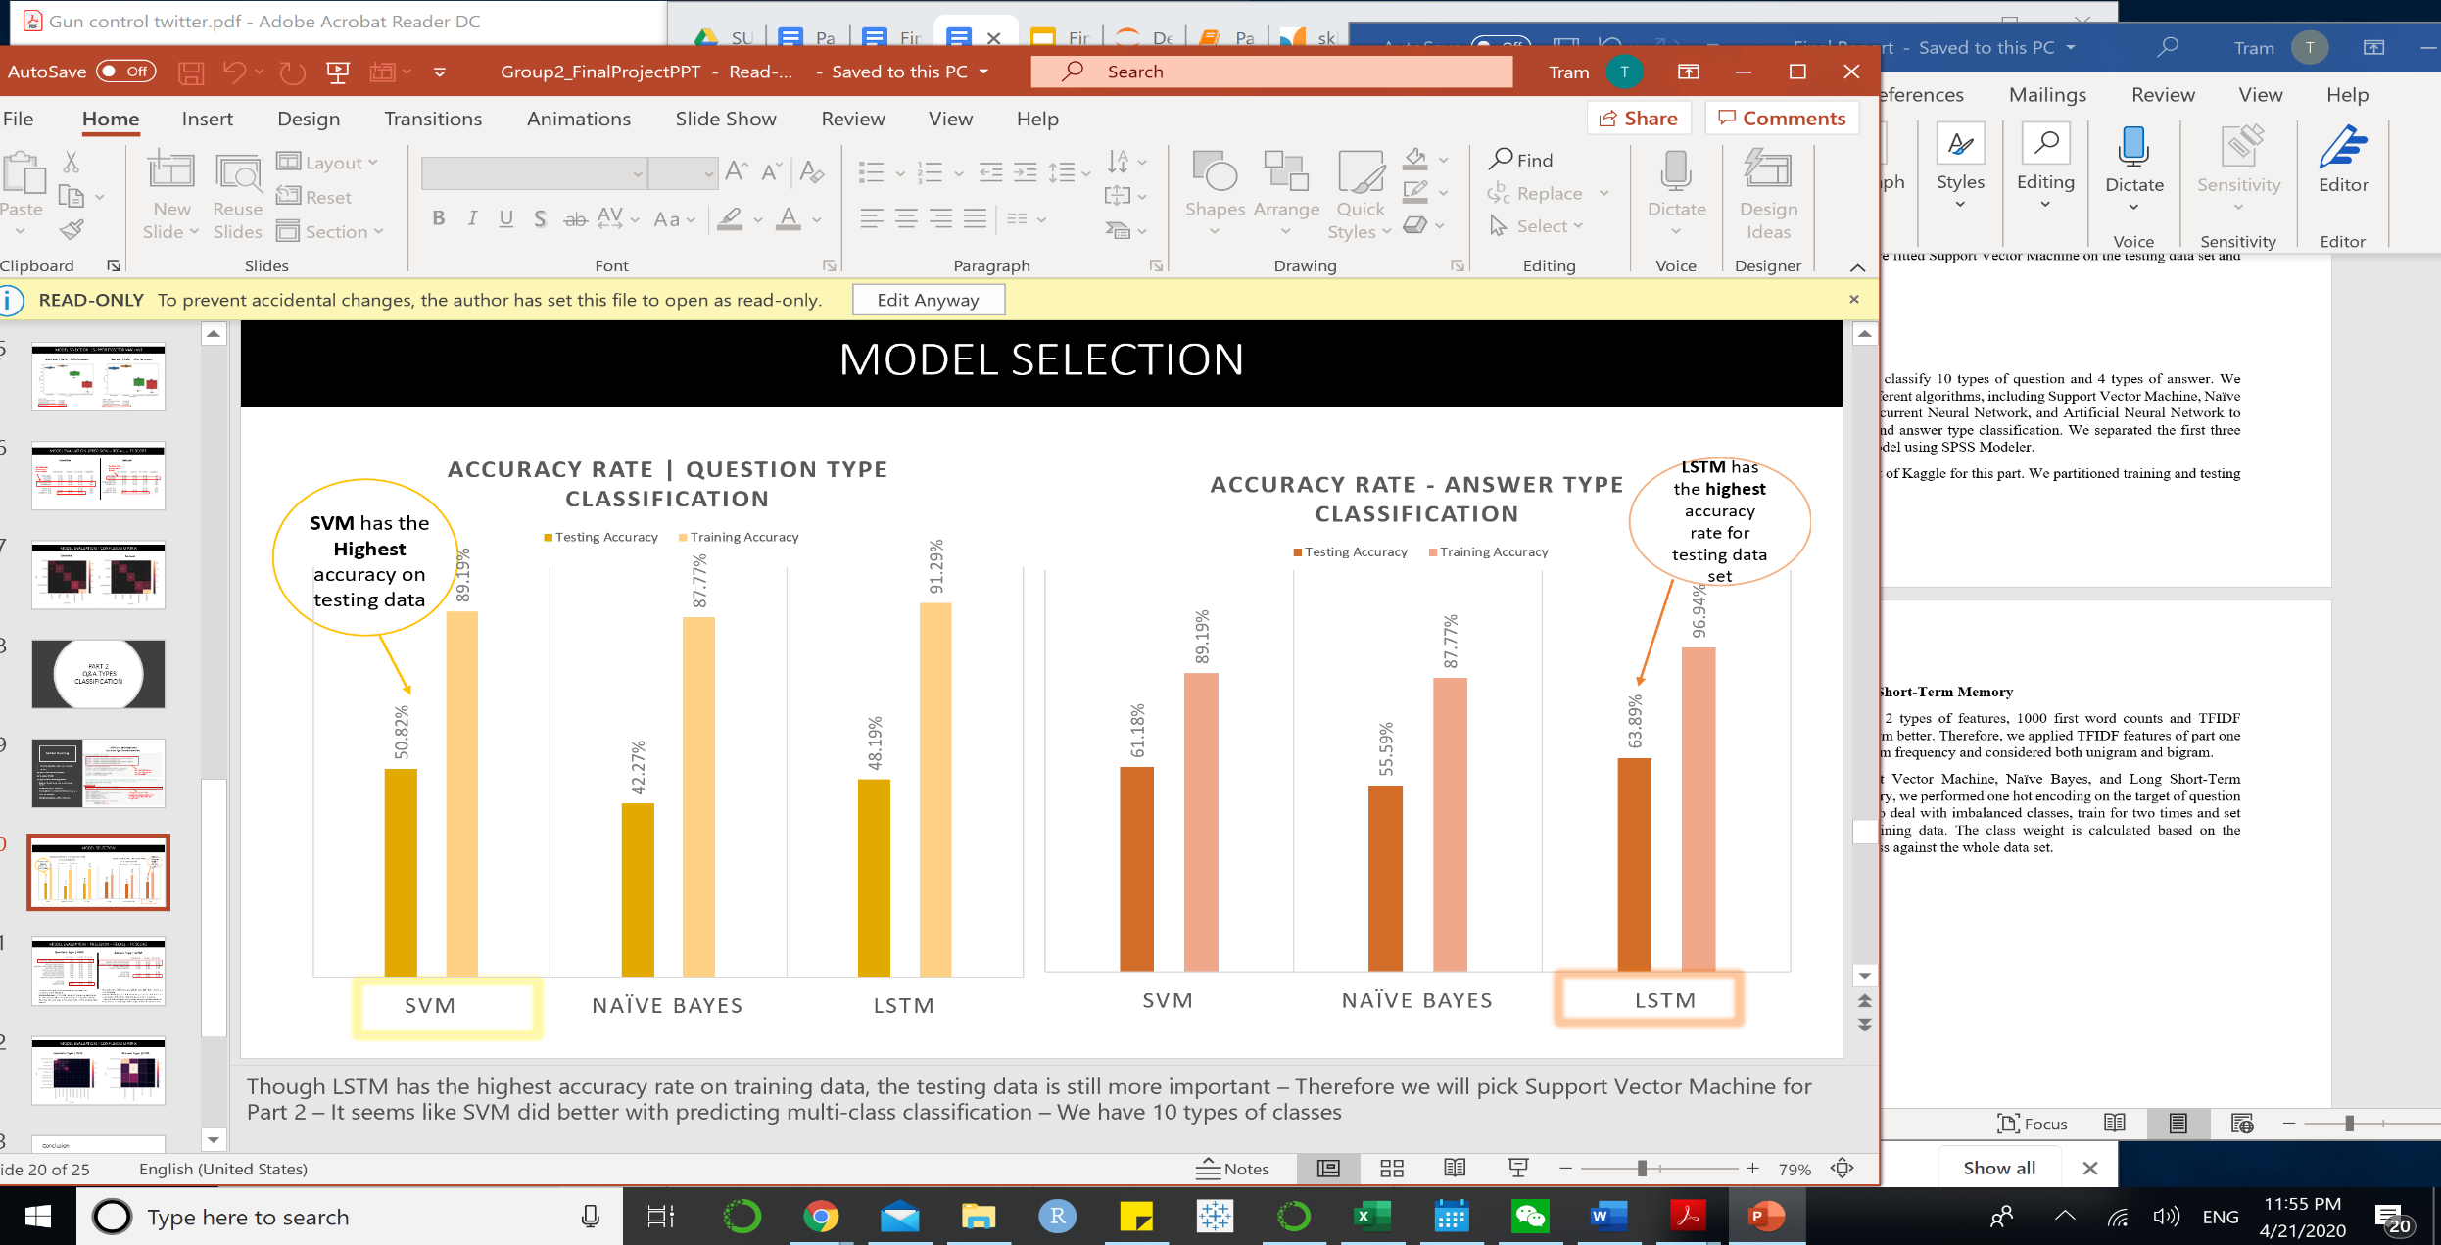Therefore, Support Vector Machine is chosen for classify 10 types of questions while Long Short-Term Memory is chosen to classify 4 types of answers.

**Figure 8. Model Selection – SVM, Naïve Bayes, LSTM (Training)**

**Model Evaluation:** In order to evaluate the model, we fit each model on testing data and use precision, recall and f1-score to evaluate the performance of each models.

For Question Type classification, Support Vector Machine predicted on an average of 0.49 precision score, 0.51 recall score and 0.49 F1-score. The model predicts on question type instruction with 0.62 of precision score, 0.78 of recall score and 0.69 F1-score. Of all the questions that are labeled as instructions, the model predicts 62% correctly out of them.

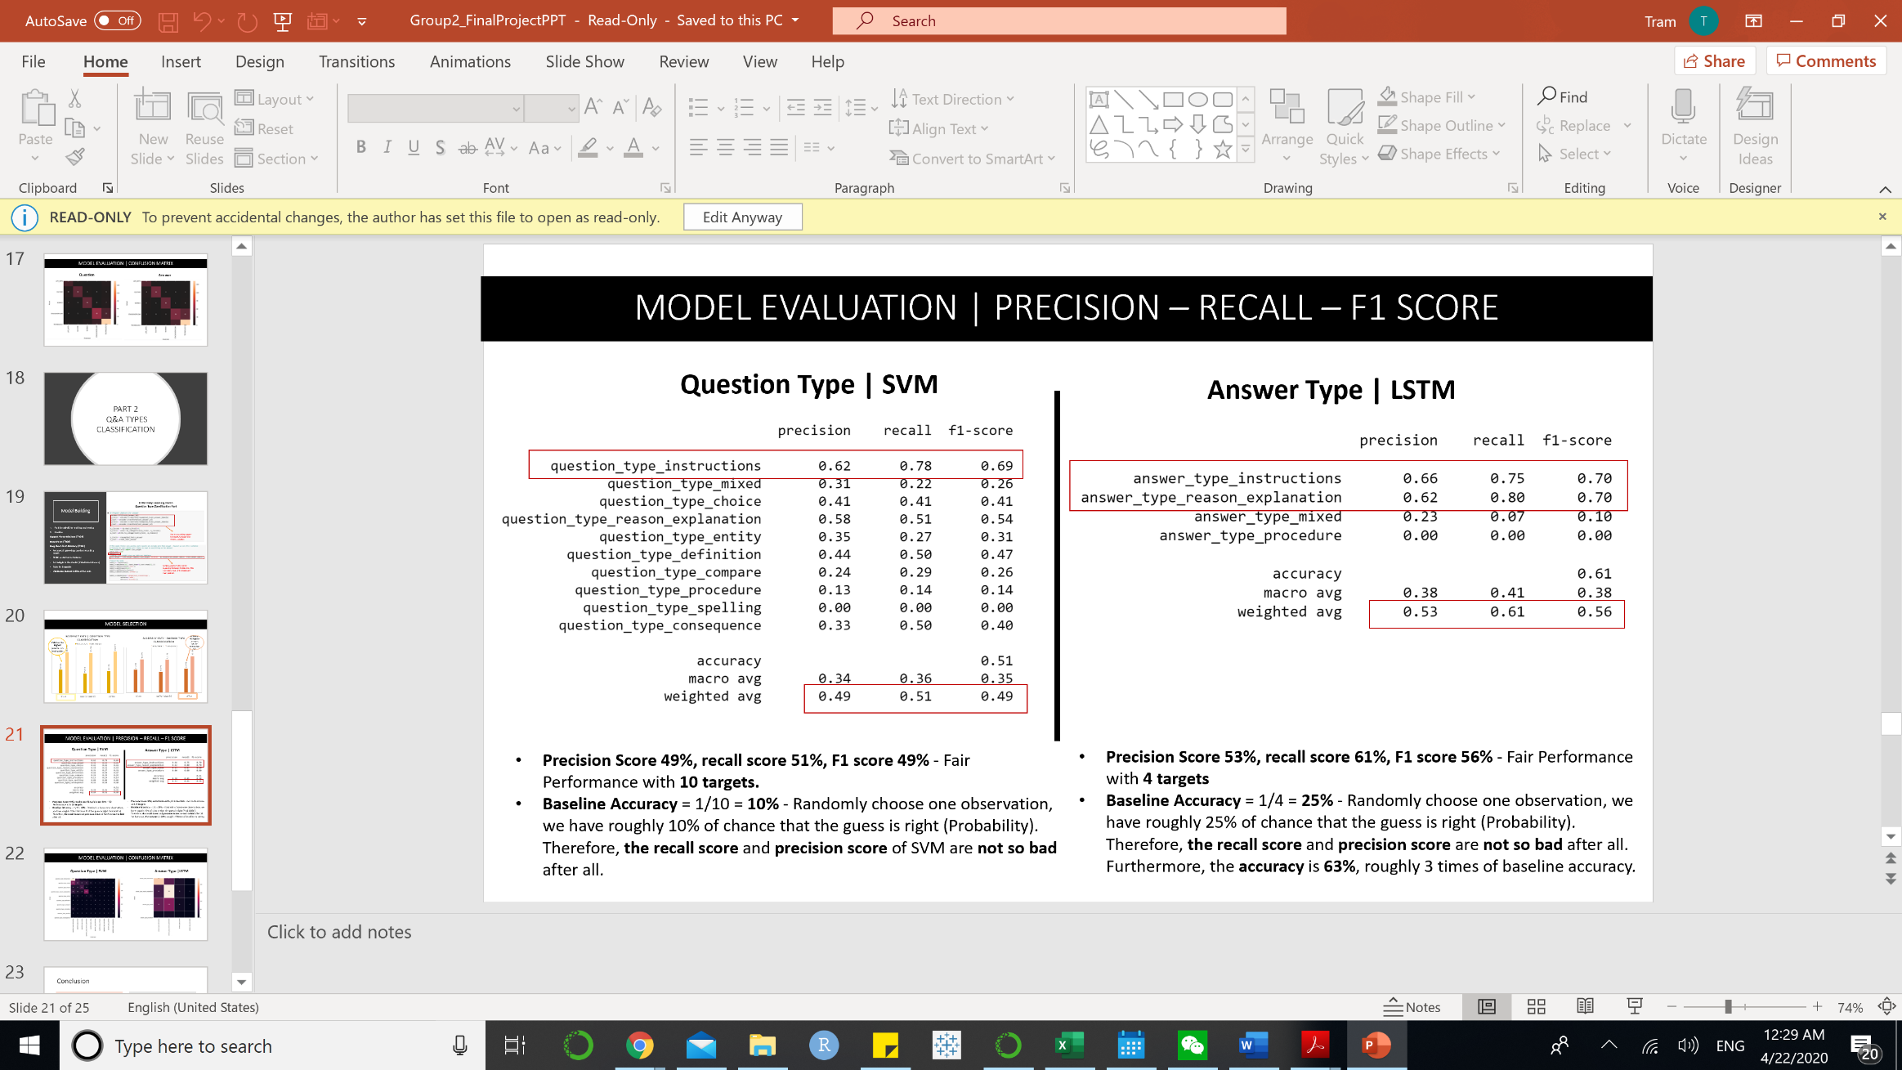For Answer Type classification, Long Short-Term Memory predict on an average of 0.53 precision score, 0.61 of recall score and 0.56 of harmony score. However, the model predicts the best on answer type instructions and answer type reason explanation while poorly predicts answer type mixed and answer type procedure. Of all the answers that are labeled as instruction and reason explanation, the model predicts 66% and 62% correctly, respectively. However, the model cannot predict any answer type procedure as all the three scores are 0.

**Figure 9. Precision, Recall, F1-Score (Testing)**

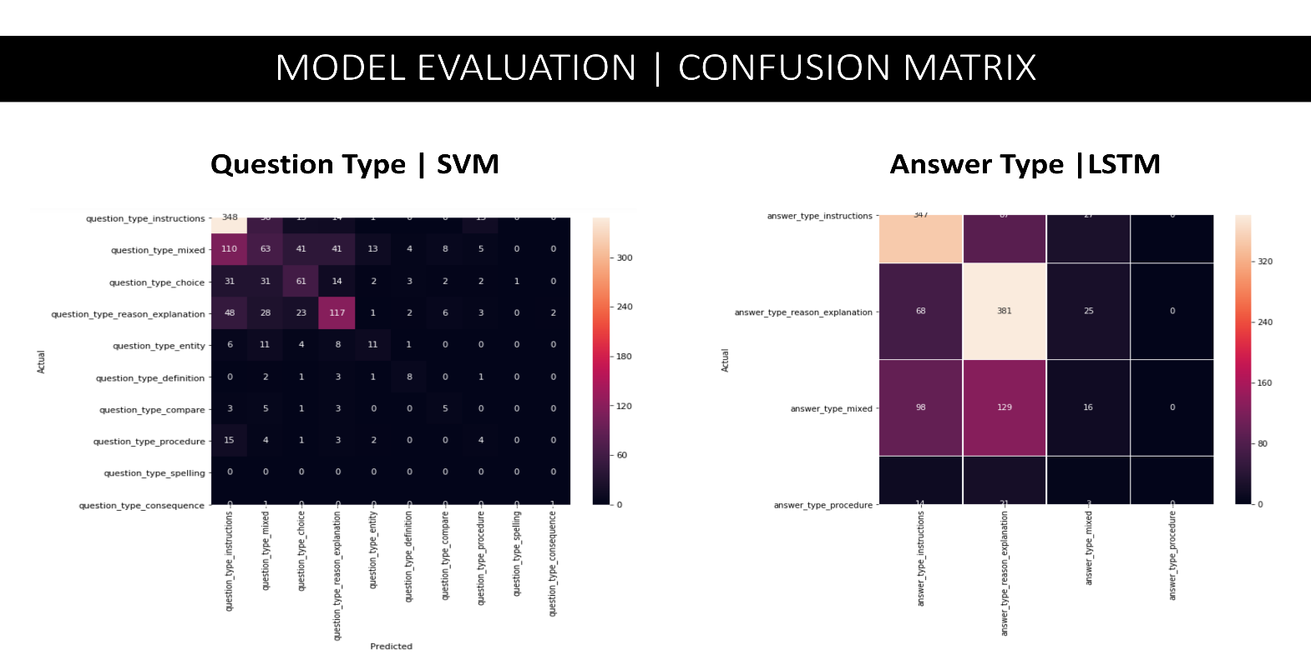**Figure 11. Confusion Matrix**

Looking at the confusion matrices of both question type and answer type predictions, we can seethat both models do not perform very well on the testing data set. The model predicted the most with question type instruction as well answer reason explanation and answer type instruction.

On the question type classification, the model tends to miss classify question mixed type with question type explanation. On the other hand, LSTM tends to miss classify answer type instruction with answer type reason explanation and answer type mixed.

* **Artificial Neural Network on SPSS**

**Feature Extraction**: In the text mining step, we used the basic resource text analytic package since the target is neither about opinion nor CRM. We just want to get the basic information of what our question/answer is talking about.

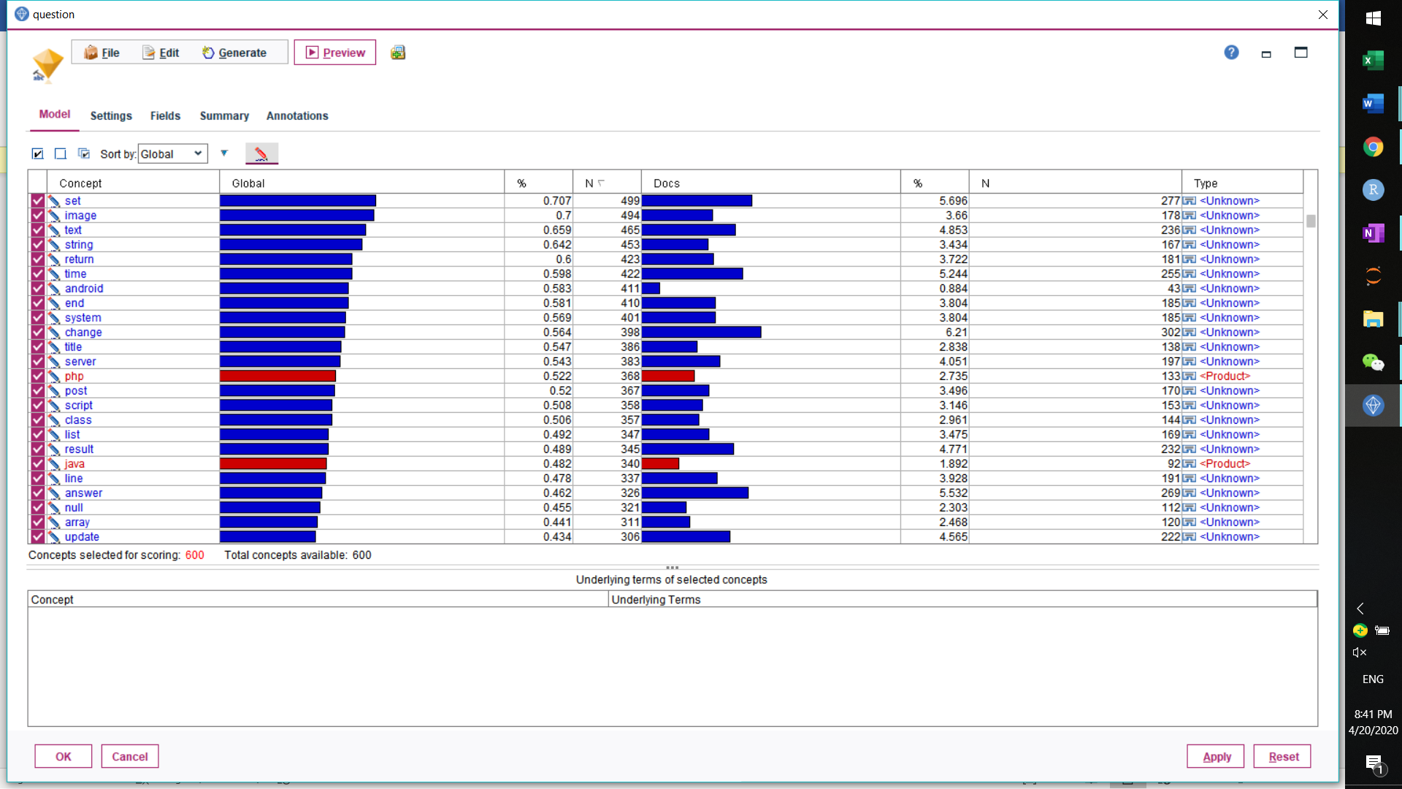

**Figure 11. Feature Extraction - Question**

In question type detection, we extract 600 concepts from the question content and use the count of those concepts as input in our model. The concepts here are basically some technical words that people asked about.

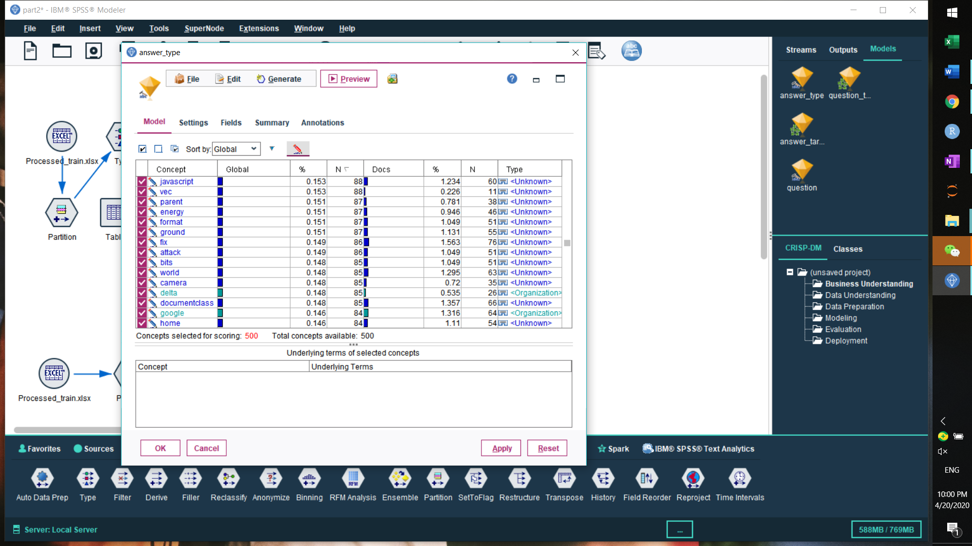

**Figure 12. Feature Extraction - Answer**

In answer type detection, we extracted 500 concepts from the answer content and used the count of those concepts as input in our model. We tried to extract more concepts like 2000 as an example, but after testing the model with multiple parameters, we decided the best concept variable number the model can deal with is around 500.

**Model Building:** Model inputs are concept counts we extracted from the text. We trained the neural net model twice: created a standard model first and retrained the model using bagging strategy to enhance the model stability. After this we have a model that ensembles multiple models and selected the best performing one.

**Model Evaluation**: For the answer type, the best accuracy we got is 58.6% for training data. The concepts that contribute most to the model are use, file, id, time, people, answer, code, etc. Those words may differ when people are answering different types of questions.

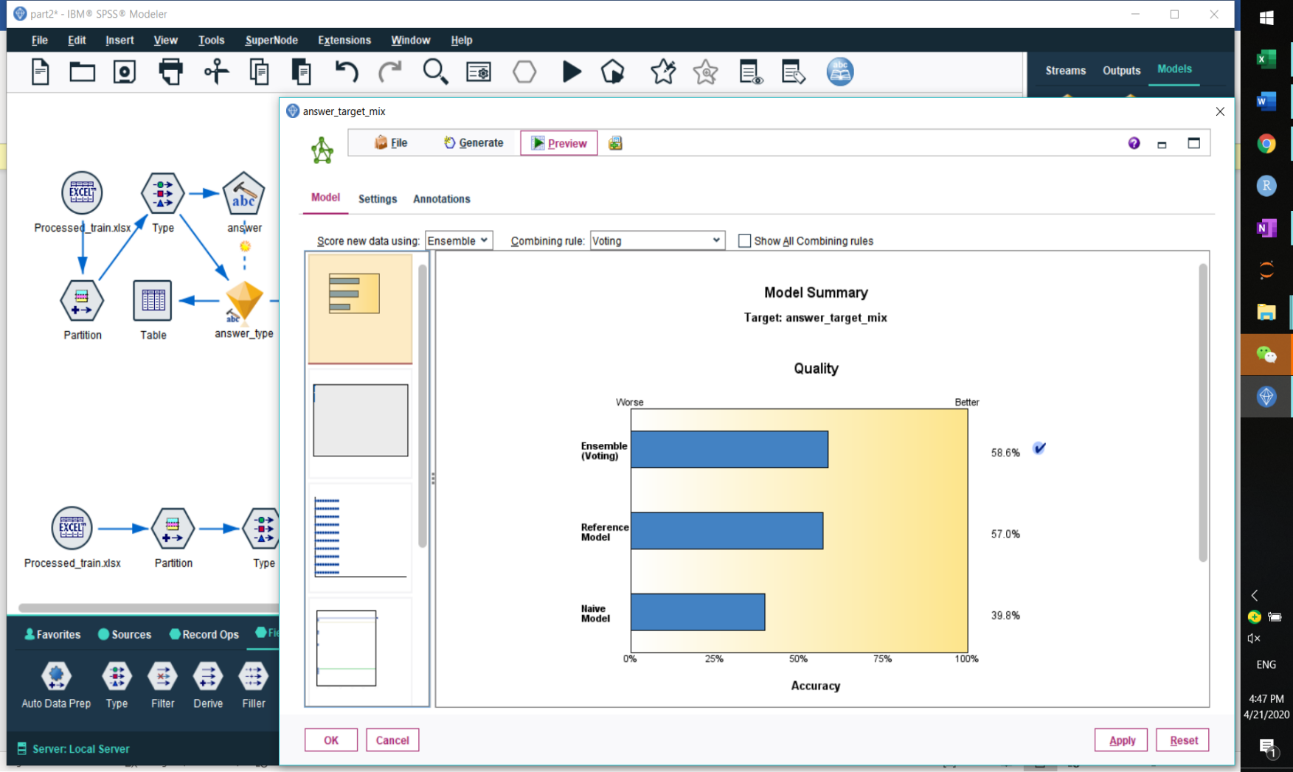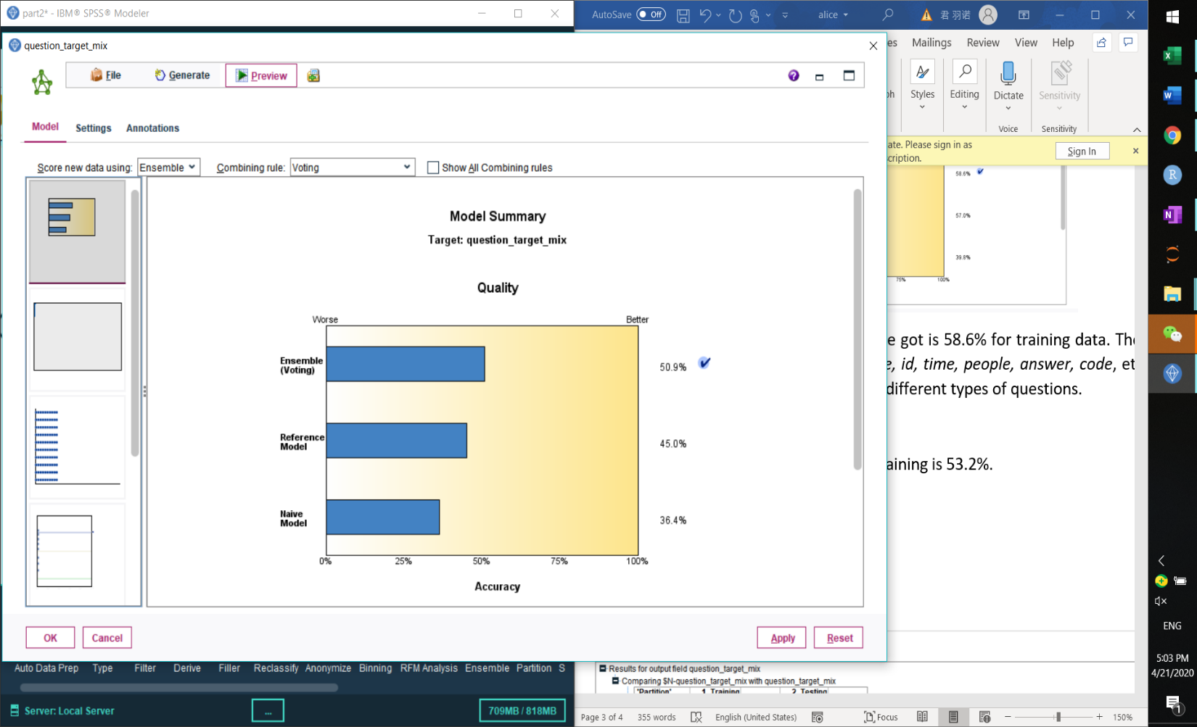For question type, the accuracy rate for training is 50.9%. The concepts that have the highest predictor importance are ball, file, meaning, help, people, data, code, value, etc. Those words are the most important differentiator when people are asking different types of questions.

**Figure 13. Accuracy Rate on Artificial Neural Network**

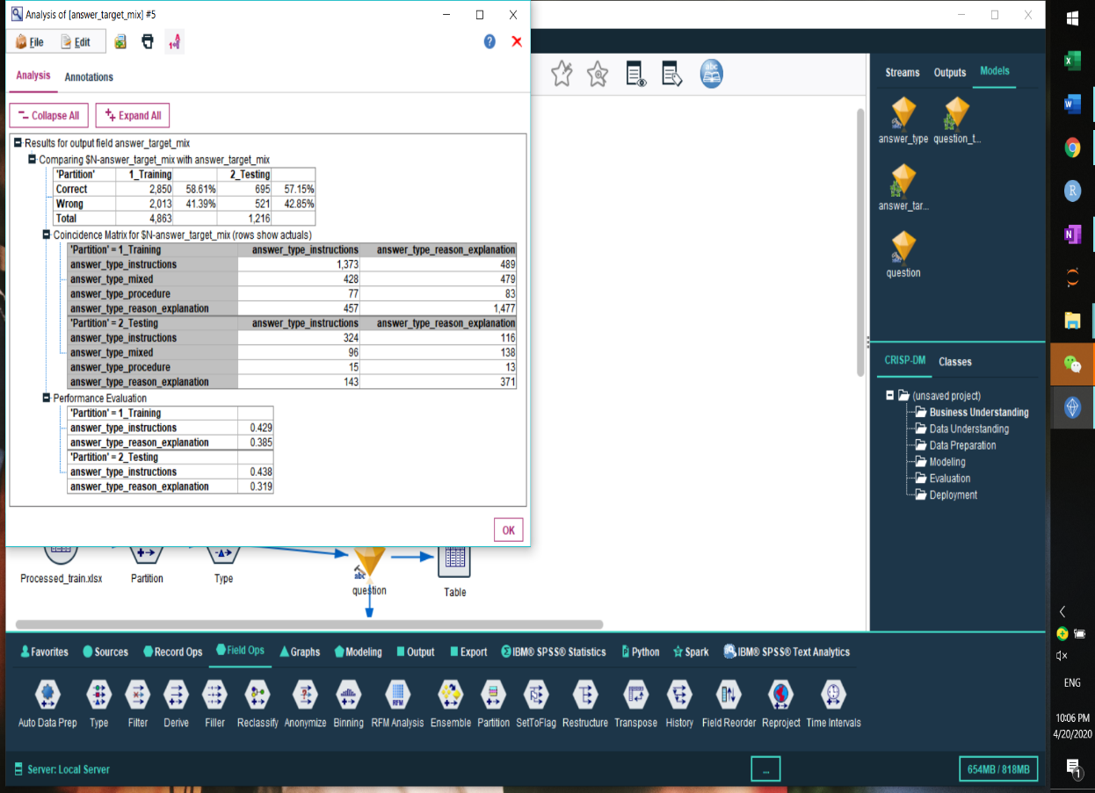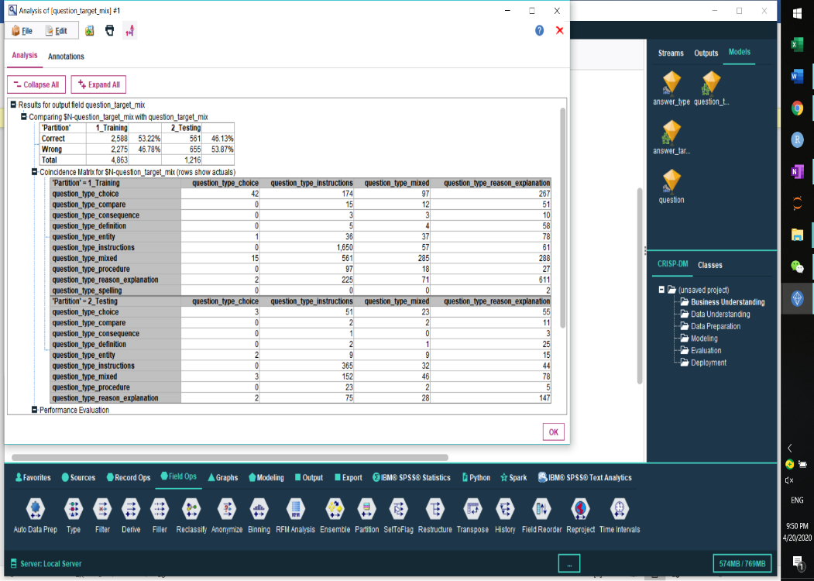**Figure 14. Confusion Matrix - Answer**

**Figure 15. Confusion Matrix - Question**

Looking at the confusion matrix, artificial neural network in SPSS modeler does not perform well either on training data or testing data. The performance are roughly 40% to 50% for both question and answer type classification. In conclusion, Support Vector Machine and Long Short-Term Memory are the best models in classify question and answer types, respectively.

1. **Results & Discussion**

Ideally, we would like to build models that can predict both the content and type of question and answer in this project.

In topic, or category, classification part, Support Vector Machine with TFIDF performs the best with an accuracy of 98% on training and a precision of 75% on testing for question, and an accuracy of 95% on training data and a precision of 74% on testing data. The performance of part one is great, especially on Culture topic.

In Q&A type classification part, Support Vector Machine performs the best for Question type classification with 89% on training yet 50% on testing. Long Short-Term Memory performs the best for answer type with about 91% on training data and 63% on testing data. However, the precision score for both question type and answer type classification on testing data ranges from 50% to 55%. There are two main reasons why models cannot perform well in this task. Firstly, TFIDF is not a good feature for distinguishing the type of a context. Secondly, there are too many types of the question-answer pair compared with the sample size. The testing data set does not provide enough observations for each type. Also, some of the types have few numbers of samples, which confuses the models. Oversampling would not help in this case since the data will be repeated generated based on only few observations. However, since the target has 10 different groups, the baseline accuracy can be considered as 10% in a random guess. In this case, an accuracy of 50% - 60% is still acceptable in our project.

1. **Recommendations**

For future improvement, we can conduct other features for distinguishing the type of a context rather than use TFIDF. For instance, we can select new features such as POS (part of speech). This feature provides tag for nouns, adjective, adverb and other tags that relating to the structure of a sentence. The structure of a sentence can probably be a better identification of types of question and answer.

Besides, combining some of the groups to balance the size among them may also improve the performance.

Finally, we would recommend collecting more data on each type and retrain the model, which can help to improve the accuracy.

1. **Conclusion**

In response to the Google question and answer classification project, we have built a model to classify topics of question and answer, Support Vector Machine with TFIDF features. However, for question and answer types classification, the Support Vector Machine and Long Short-Term Memory should be retrained again with different features and more data. Our model for content classification can contribute to the Q&A systems research in an effort of making the system become more human-like.

**Reference**

1. Li, Susan. “Multi-Class Text Classification with Scikit-Learn.” Medium, Towards Data Science, 20 Feb. 2018, towardsdatascience.com/multi-class-text-classification-with-scikit-learn-12f1e60e0a9f.

2. Javaid, Nabi. “Machine Learning Multiclass Classification with imbalanced data set.” Medium, Towards Data Science, Dec 22, 2018, [towardsdatascience.com/machine-learning-multiclass-classification-with-imbalanced-data-set-29f6a177c1a](https://towardsdatascience.com/machine-learning-multiclass-classification-with-imbalanced-data-set-29f6a177c1a).

3. “A Gentle Introduction to Imbalanced.” Machine Learning Mastery, Jan. 14, 2020, machinelearningmastery.com/what-is-imbalanced-classification.

4. “Best Algorithm for Classification.” Kaggle, kaggle.com/getting-started/42409.

5. Mohammed Terry-jack, “Tips and Tricks for Multi-class Classification.” Medium, Towards Data Science, Apr. 28, 2019, medium.com/@b.terryjack/tips-and-tricks-for-multi-class-classification-c184ae1c8ffc